

Functional Requirements Document
[Sailing Club]

Document History:

Current Version: | 1.0
Authors: | Kingsley Vanessa  (vanessaehimwenma.kingsleyovbiolokun@studenti.unipr.it)  Casciana Andrea  (andrea.casciana@studenti.unipr.it )
Date Created: | January, 2022
Date Last Updated:
Last Updated by:

Università degli studi di Parma

via Università, 12 - I 43121 Parma ▪ Italy

Revision History:

Version | Description of Change | Author | Date

CONTENTS
1 INTRODUCTION 5
1.1 Purpose 5
1.2 Scope 5
1.3 Background 5
1.4 References 5
1.5 Assumptions and Constraints 5
1.6 Document Overview 5
2 METHODOLOGY 5
3 FUNCTIONAL REQUIREMENTS 6
4 USE CASE DIAGRAM 7
5 CLASS DIAGRAM 8
6 SEQUENZE DIAGRAMS 12
APPENDIX A - GLOSSARY 14

INTRODUCTION
A client-server software system to manage a Sailing Club

Purpose
The purpose of this functional and requirements document is to provide documentation to prospective solution providers on the requirements to implement and operate a Sailing Club client-server system.

Scope
This Functional Requirements Document will outline the functional, performance, security and other system requirements identified as the proposed information system solution for a Sailing Club software system

Background
This is a group project to be developed by the authors (Kingsley Vanessa and Casciana Andrea) in their various functionalities.

References

Assumptions and Constraints

Assumptions

Constraints

Document Overview

METHODOLOGY
The overall approach used in the determination of this functional requirements document is mostly about analyzing in-depth the outline of the expected results given, while putting into consideration other aspects that may arise.

FUNCTIONAL REQUIREMENTS

# | Requirement Definition | User  Category
1 | The system shall memorize personal details. | Member/Staff/Boat/Race
2 | The system shall allow member to own boats. | Member
3 | The system shall allow member to add boats to existing ones. | Member
4 | The system shall allow member to remove boats from existing ones. | Member
5 | The system shall allow payment of annual membership fee. | Member
6 | The system shall allow payment of annual storage fee of each boat. | Member
7 | The system shall organize races of the boats of their members. | Club/Admin
8 | The system shall allow any member to enroll a boat by paying an enrollment fee. | Member
9 | The system shall allow connections to the server through login details. | Member/Staff
10 | The system shall sends notifications, notifying members to renew their membership or storage fee. | Staff/Member
11 | The system shall maintain traces of all payments  (membership, storage, enrollment) | System/Staff
12 | The system shall offer a system of payment.  (credit card, transfer) | System

USE CASE DIAGRAM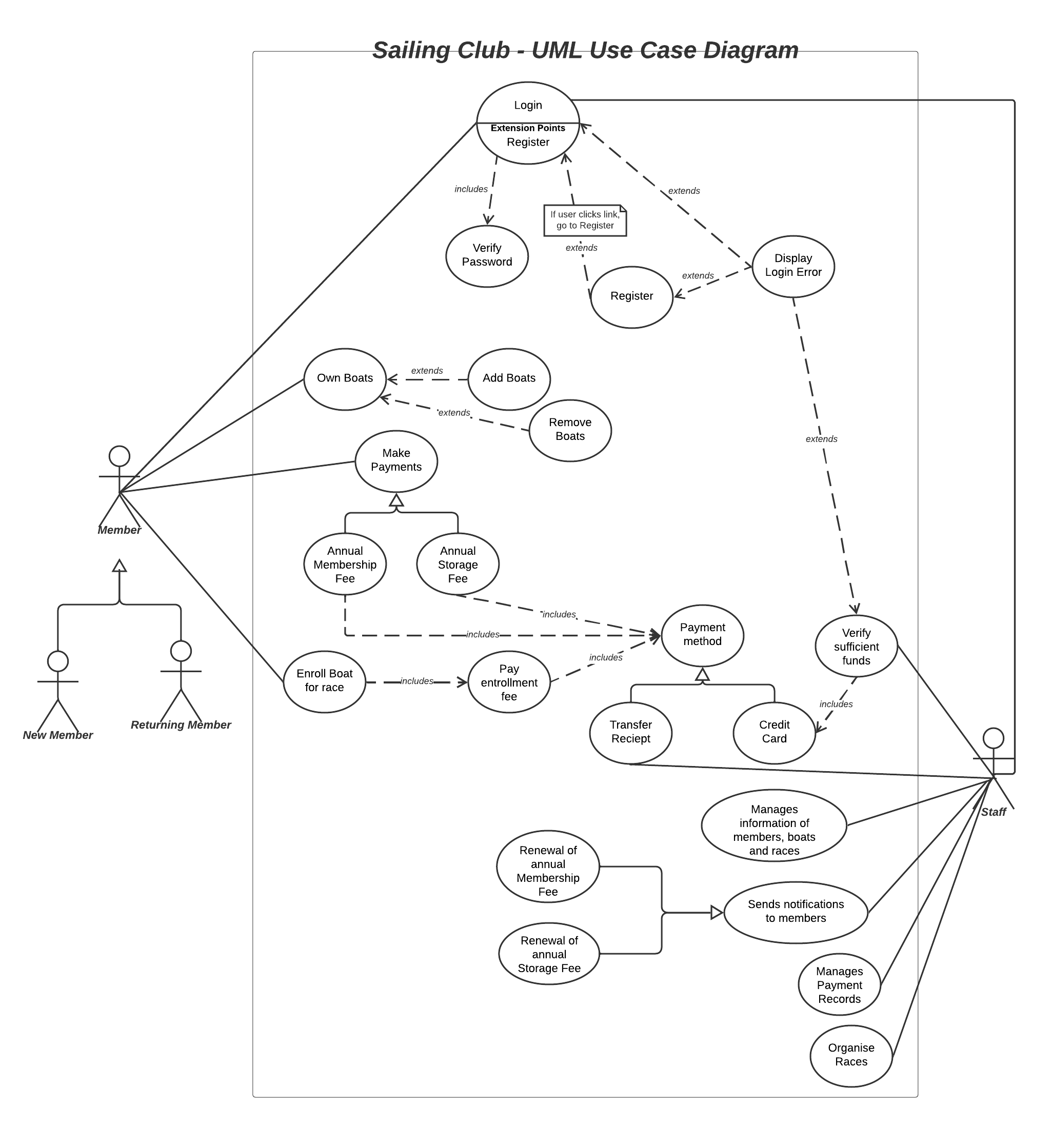

CLASS DIAGRAM
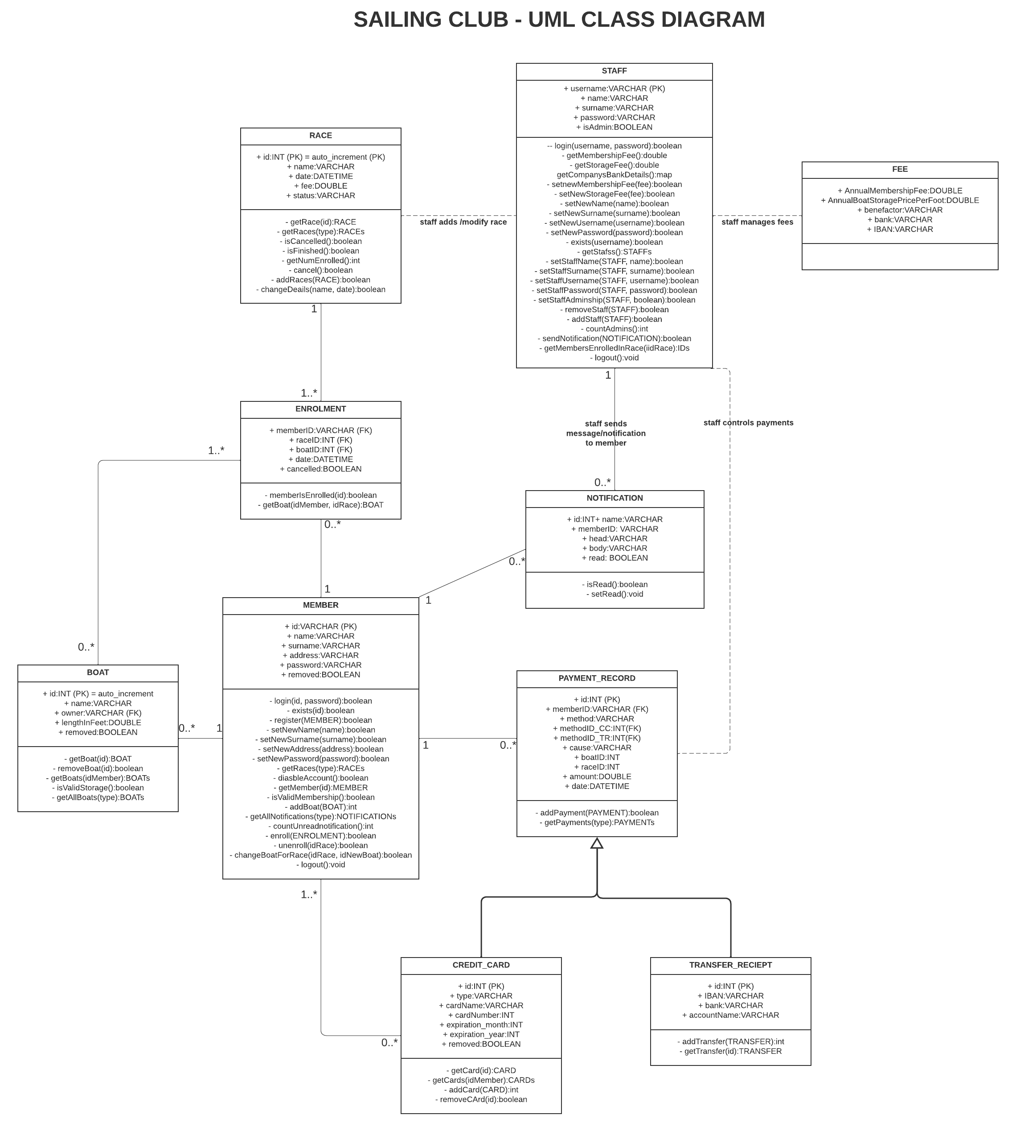

Definitions of the tabular description.

create table if not exists member
(
name VARCHAR(50) not null,
surname VARCHAR(50) not null,
address VARCHAR(50),
id VARCHAR(16) not null,
password VARCHAR(50) not null,
removed BOOLEAN not null,

PRIMARY KEY (id)
);

create table if not exists boat
(
id INT AUTO_INCREMENT,
name VARCHAR(50) not null,
owner VARCHAR(16) not null,
lengthInFeet DOUBLE not null,
removed BOOLEAN not null,

PRIMARY KEY (id),
FOREIGN KEY (owner) references member(id) ON UPDATE CASCADE ON DELETE CASCADE
)AUTO_INCREMENT = 1000;

create table if not exists staff
(
id INT AUTO_INCREMENT,
name VARCHAR(50) not null,
surname VARCHAR(50) not null,
username VARCHAR(50) not null,
password VARCHAR(50) not null,
isAdmin BOOLEAN not null,
removed BOOLEAN not null,

PRIMARY KEY (id),
UNIQUE(username)
)AUTO_INCREMENT = 1000;

create table if not exists race
(
id INT AUTO_INCREMENT,
name VARCHAR(50) not null,
date DATETIME not null,
fee DOUBLE not null,
cancelled BOOLEAN not null,

PRIMARY KEY (id)
)AUTO_INCREMENT = 100;

create table if not exists enrolment
(
memberID VARCHAR(16) not null,
raceID INT not null,
boatID INT not null,
date DATE not null,
cancelled BOOLEAN not null,

UNIQUE(memberID,raceID),
FOREIGN KEY (memberID) references member(id) ON UPDATE CASCADE,
FOREIGN KEY (raceID) references race(id) ON UPDATE CASCADE,
FOREIGN KEY (boatID) references boat(id) ON UPDATE CASCADE
);

create table if not exists credit_card
(
id INT AUTO_INCREMENT,
type VARCHAR(50), -- visa, mastercard, ecc
cardName VARCHAR(50) not null,
cardNumber BIGINT not null,
exp_month INT not null,
exp_year INT not null,
removed BOOLEAN not null,

PRIMARY KEY (id)
)AUTO_INCREMENT = 1000;

create table if not exists transfer_reciept_details
(
id INT AUTO_INCREMENT,
IBAN VARCHAR(50) not null,
bank VARCHAR(50) not null,
accountName VARCHAR(50) not null,

PRIMARY KEY (id)
)AUTO_INCREMENT = 1000;

create table if not exists payment
(
id INT AUTO_INCREMENT,
memberID VARCHAR(16) not null,
method VARCHAR(50) not null, -- card or transfer
methodID_CC INT,
methodID_TR INT,
cause VARCHAR(50) not null, -- membership fee, storage fee
boatID INT,
raceID INT,
amount DOUBLE not null,
date DATE not null,

PRIMARY KEY (id),
FOREIGN KEY (memberID) references member(id) ON UPDATE CASCADE,
FOREIGN KEY (methodID_CC) references credit_card(id) ON UPDATE CASCADE,
FOREIGN KEY (methodID_TR) references transfer_reciept_details(id) ON UPDATE CASCADE,
FOREIGN KEY (raceID) references race(id) ON UPDATE CASCADE,
FOREIGN KEY (boatID) references boat(id) ON UPDATE CASCADE
)AUTO_INCREMENT = 100;

create table if not exists notification
(
id INT AUTO_INCREMENT,
memberID VARCHAR(16) not null,
head VARCHAR(100) not null,
body VARCHAR(300),
date DATE not null,
opened BOOLEAN not null,

PRIMARY KEY (id),
FOREIGN KEY (memberID) references member(id) ON UPDATE CASCADE
)AUTO_INCREMENT = 1000;

create table if not exists club_details -- details of the club defined that can be modified
(
AnnualMembershipFee DOUBLE not null,
AnnualBoatStoragePricePerFoot DOUBLE not null,
benefactor VARCHAR(50) not null,
bank VARCHAR(50) not null,
IBAN VARCHAR(34) not null
);

SEQUENCE DIAGRAM
- Membership Renewal 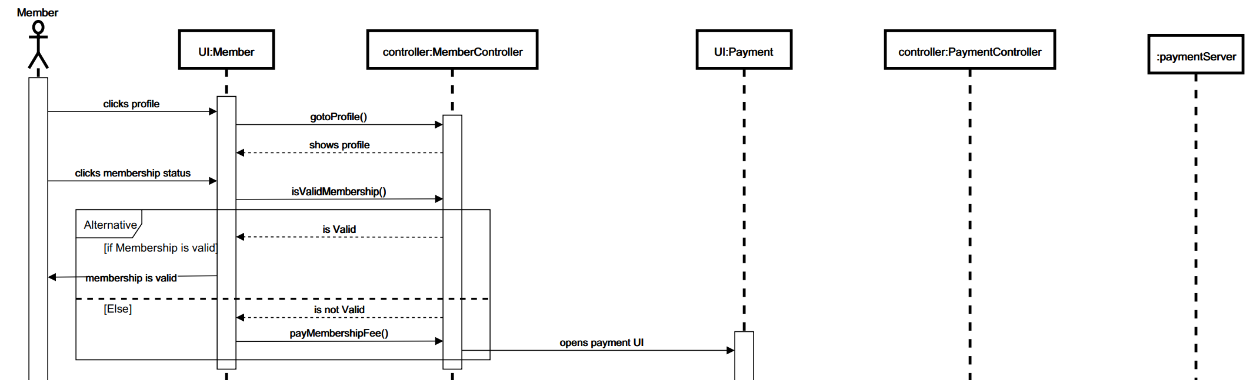

- Add New Boat 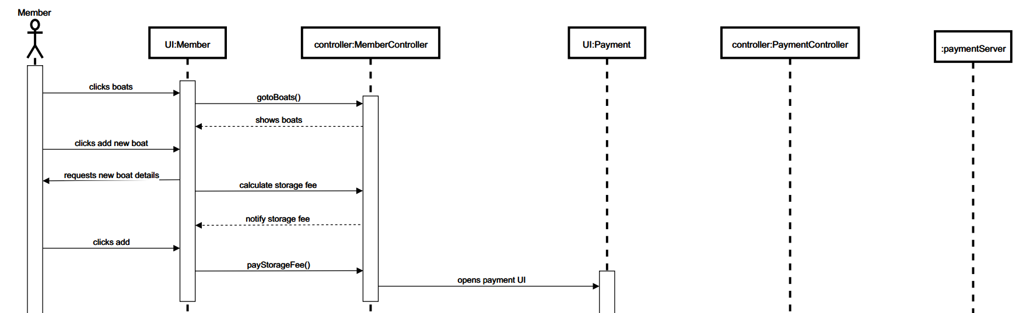

- Race Enrolment 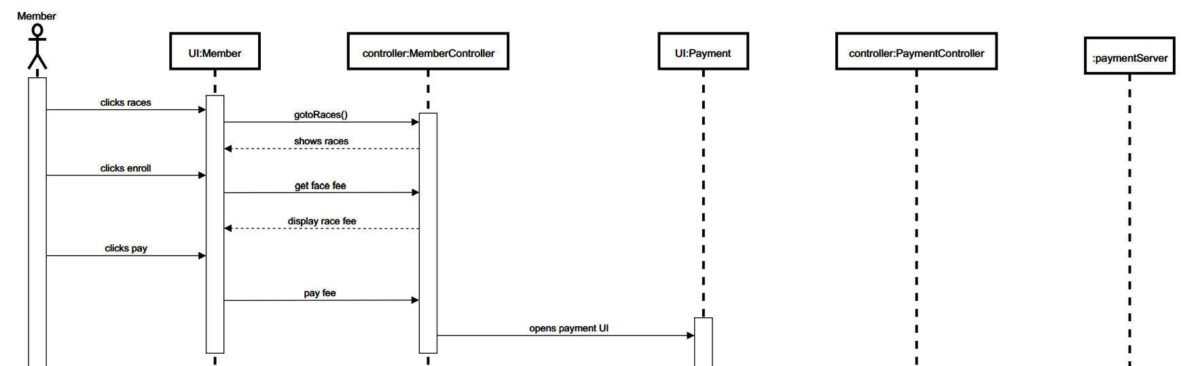

- General Payment Sequence Diagram
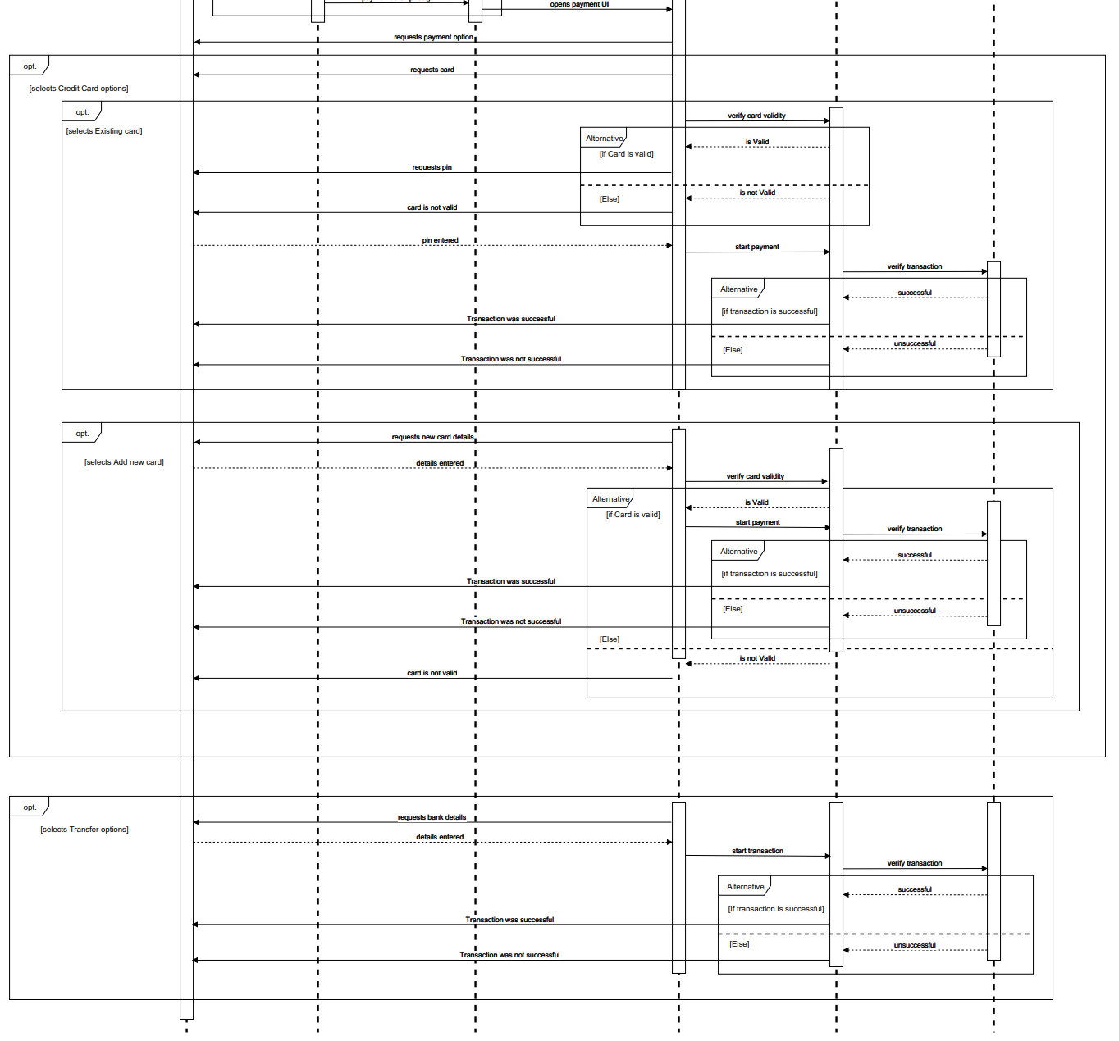

APPENDIX A - GLOSSARY

